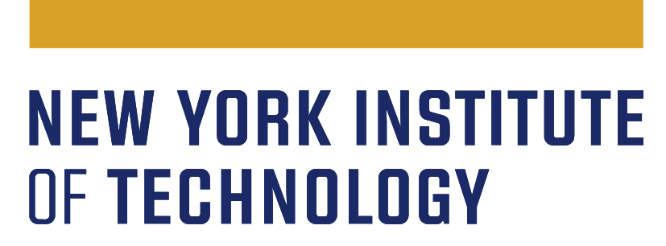
Continuous Program Improvement (CPI)
Student Success/Achievement
Three Year Plan - 2022-2025

Department name
Expected date of submission | 06/30/2022
Department contact
Dean’s signature

The Middle States Commission on Higher Education (MSCHE) Standard V, Educational Effectiveness Assessment, states: “Assessment of student learning and achievement demonstrates that the institution’s students have accomplished educational goals consistent with their program of study, degree level, the institution’s mission, and appropriate expectations for institutions of higher education.”
To ensure that New York Tech’s CPI process meets this standard, each department is requested to create a three-year assessment/evaluation plan to improve student success/achievement. The plan should cover the following academic years: 2022-2023, 2023-2024, and 2024-2025.

The student success/achievement CPI plan should include the following:
- State the educational goals of your department regarding student achievement at the degree/program level.
The stated goals should align with our institutional mission and New York Tech strategic action plan goals to optimize student success.

- Present data analyses (current and historical), research, and/or other relevant information that identify obstacles and challenges for which a quality improvement action plan can be proposed.

- Your department’s action plan should address the following:
- What are the goals of the action plan? (Make them S.M.A.R.T.: Specific, Measurable, Actionable, Relevant, and Time-based)
- What are the strategic actions to improve?
- What are the key performance indicators (KPI), both qualitative and quantitative, used to assess the actions’ effectiveness?
- Describe how your department established the baseline and expected outcomes (this could be the successful goal or stages toward the successful goal), as well as the methods used to evaluate progress, adjust the action, and determine its effectiveness.
- Identify personnel/leadership involved and resources needed to implement the plan.
- Collect and analyze the data; if the expected outcomes are successfully met, maintain and/or expand the practice, otherwise refine the plan and begin the next cycle of Plan-Do-Study-Act.

- Explain how the plan and results will be conveyed to your department. (It is strongly recommended that all stakeholders, including students, are involved in the CPI process.)

https://www.nyit.edu/planning/demings_model_for_continuous_improvement

One Example of CPI Plan:
Chemistry Department, Fictitious University

- State/create the educational goals of your department regarding student achievement at the degree/program level.

B.S. Chemistry Program Educational Goals:
Students successfully graduating from B.S. chemistry program will be prepared to pursue careers in science, health professions, K-12 education, as well as advanced studies in their chosen path.
Key performance indicators: graduation rate, rate of job placement or pursuit of advanced study.

- The stated goals should align with institutional mission, and NYIT strategic action plan goals to optimize student success.
Align with the university mission: Provide career-oriented professional education.
Align with the university strategic goal of optimizing student success.

- Specify current and historical student data analysis or relevant information that identify the obstacles and discover areas of opportunity for improvement.

      - Current and historical data that identify areas for improvement.
Our department reviewed the six-year graduation rate of the BS chemistry, and benchmark against peer institution, which indicate the room for improvement.

Term | Start Cohort | Grad | Grad Year 6 | Peer Grad Year 6
Fall 2019 | 173 | 107 | 62% | 70%
Fall 2020 | 146 | 86 | 59% | 69%
Fall 2021 | 173 | 88 | 51% | 72%
Fall 2022 | 180 | 104 | 58% | 77%

      - Data analysis and relevant research are sufficient to propose quality improvement initiatives.
Based on educational research (quote source here), students failing or withdrawing from required courses is one of the important reasons that prevent students from completing their degree or delaying their graduation. Therefore, we examined DFW rate across courses. Among all the course offered in our department, chem 110 has the highest DFW rate in average: 20%, however, across 5 sections, the D.F.W rate vary significantly from 1% to 41%, see the table below:
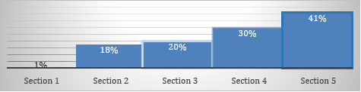

Diagnose questions: is the variation of DFW rate caused by different instructor using different tests, and different course content? If yes, consistency needs to be made across sections, then re-exam the DFW rate again.

Because our department uses the same test and same syllabus across sections and instructors, our answer to the diagnose question is no, confirmed by all instructors. Therefore, our diagnosis went on to student preparedness: We analyzed the admission GPA of our students across five sections.

CHEM 110 | Numbers of students | Admission GPA |  | difference from sec.1. stat. sig.
Section 1 | 20 | 3.8 |  | ￼
Section 2 | 28 | 3 |  | **
Section 3 | 19 | 2.9 |  | **
Section 4 | 22 | 3.1 |  | **
Section 5 | 23 | 2.8 |  | **

The cross-section student GPA analysis indicates that section 2, 3, 4, are significantly lower than section 1. Underprepared students, especially those in section 2, 3, 4 need remedial options before taking chem 110, which we expect could decrease the DFW rate and increase their chances to graduate on time.

- Specify your division/department strategic action/initiatives plans with the following:
The department plan to provide remedial summer courses for students with a gap of less than 3 in the summer session 3 weeks before semester starts.
- What are the student success goals (Make it smart: specific, measurable, actionable, relevant, and time-based)
We expected to improve the graduation rate to 70% comparable to or better than our peers in the next three years.
- What are the strategic actions to improve?
Provide summer remedial courses 3 weeks before semester begins.
- What are the KPI (both qualitative and quantitative measures) used to assess the actions’ effectiveness?
Chem 110 course DFW rate across sections, student course survey, and graduation rate after 4 years.
- Describe how the department set up the baseline and expected outcomes (could be the successful goal or stages towards the successful goal), the methods to evaluate progress, adjust its actions and determine its effectiveness?(see it in the table below)
- Identify personnel/leadership, resources to implement the plan, collect and analyze the data and identify if the expected outcomes are met. If successfully met, keep the practice or expand, if not, refine and next cycle of PDSA begin (see it in the table below)

)
Actions | KPIs | Baseline & Expected outcomes, by AY 2024-2025 | Do: Resources & responsible parties | Study: Timeline: Data collecting & analysis | Recommendations for Action
Provide remedial summer course for unprepared students for chem 110 | - Student admission GPA  - DFW rate of chem 110  - Chem 110 student survey | Baseline: 20% of DFW rate.  Expected Chem 110 DFW rate drop to 5-10% | - Instructors who teach chem 110  - 2 students tutors  - Department chair provide leadership and support | By the end of chem 110. | TBD

- How will the plan and results be conveyed to your department?
This plan and results will be shared with all faculty and staff in the department meeting. If the remedial course reduces the DFW rate by the end of the semester, we will keep the summer prep course, if not, we will study the results and find out other approaches to help student success.
Students will be recruited through the admission office.

