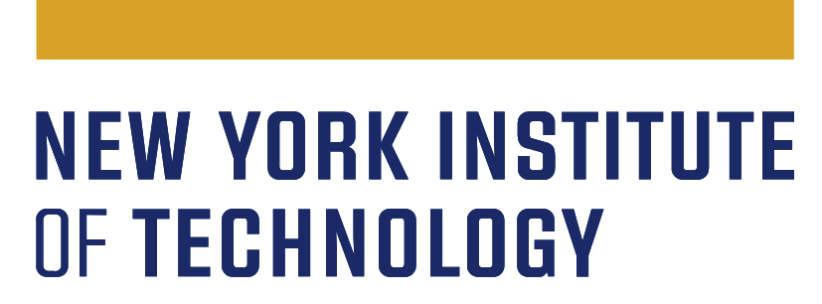
Continuous Program Improvement (CPI)
Student Learning Outcomes (SLO)/Program Learning Outcomes (PLO)
Three Year Plan - 2022-2025
Program name
Expected date of submission
Department chair/program director
Dean’s signature

The Middle States Commission on Higher Education (MSCHE) Standard V, Educational Effectiveness Assessment, states: “Assessment of student learning and achievement demonstrates that the institution’s students have accomplished educational goals consistent with their program of study, degree level, the institution’s mission, and appropriate expectations for institutions of higher education.”
To ensure that New York Tech’s CPI process meets this standard, each department is requested to create a three-year assessment/evaluation plan to improve student learning for each of their degree programs. The plan should cover the following academic years: 2022-2023, 2023-2024, and 2024-2025.

Each Program Learning Outcomes (PLO) CPI plan should include the following:
- State/update each degree program’s learning outcomes based on the Program Assessment Guidelines and Best Practices.The original Program Learning Outcome Assessment Plans and Reports are available here: http://www.nyit.edu/planning/academic_assessment_plans_reports.

- Provide/update the matrix of program learning outcomes that indicates which learning outcomes are assessed in which courses. The original matrices are available here: http://www.nyit.edu/planning/academic_assessment_plans_reports.

- Describe the method of assessment and measurement instruments (e.g., rubric, exam items, scoring guide for a particular task, supervisor evaluation form, and standardized assessment tool). Note: Direct evidence of student learning is required; both direct and indirect evidence are strongly recommended. [Direct evidence of student learning includes but is not limited to: course assignments, portfolios, internship evaluations, capstone course work, thesis papers, research projects, standardized tests, etc. Indirect evidence of student learning includes but is not limited to: student surveys, interviews, alumni surveys, employer surveys, focus groups, students’ reflections, etc.]

- A timeline of when each PLO will be assessed; for example:
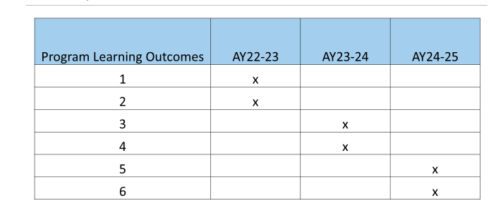

- Faculty working as a team is essential in program learning outcome assessment. Please provide a brief description of how faculty are involved in the creation of this assessment plan and how the results will be communicated to all stakeholders.

