2021 Institutional Support of Research and Creativity (ISRC) and

Teaching and Learning with Technology (TLT) Grants Program

The New York Institute of Technology (NYIT) invites faculty to apply to the ISRC and/or TLT Grants Program. ISRC and TLT Grants are intended to seed:

faculty research, scholarship, and creative activity, and

faculty innovation in the usage of technology to enhance pedagogy and strengthen

teaching and learning.

Priority will be given to high quality proposals submitted by new investigators and/or investigators conducting highly innovative work that represents a significant change in research direction or tests new methods or techniques.

Applications are due on December 4, 2020. Grants can begin as early as July 1, 2021, and one-year grants end by June 30, 2022. Guidelines and application forms for these grants are available from the Deans, from the Academic Affairs web site at: https://www.nyit.edu/academic_affairs/faculty_forms_resources and from the Sponsored Programs and Research web site at https://www.nyit.edu/ospar/internal_grants/.
WHO CAN APPLY?

Tenured, tenure-track faculty, clinical track and teaching track members of the AAUP covered by the Collective Bargaining Agreement at NYIT are welcome to apply as Principal Investigators. Other NYIT full-time faculty (including NYIT College of Osteopathic Medicine and global faculty) may be included on the application as Co-Principal Investigators, Co-Investigators, Collaborators, or project Consultants. However, the maximum number of applications on which an individual faculty member can be listed in a single year is two (2).
Any individual faculty member can request release time from only one application.
WHAT ARE THE FUNDING PRIORITIES OF THE ISRC AND TLT PROGRAMS?

Faculty are encouraged to submit proposals that show potential for attracting external grant funding and which are likely to result in some sort of permanent advancement of the field (e.g., a published paper, an art show, or a funded grant). It is important to include any information regarding external funding secured from previous ISRC grants for any new applications.
WHAT KIND OF PROJECTS ARE FUNDED?

- Preliminary research that will result in the submission of a major (i.e., large-budget) external grant proposal (ISRC Grant)
- High quality scholarly level research in an academic discipline (ISRC Grant)
- Significant creative work such as preparation for a major art exhibit (ISRC Grant)
- Preparation of books and the like for high quality venues (ISRC Grant)
- Preparation of classroom projects specifically designed to involve NYIT students in research or other scholarly pursuits that are not already part of a course (ISRC Grant, or TLT Grant if technology is involved)
- Pedagogical ideas that will result in submission of grants to the National Science Foundation, U.S. Department of Education, National Institutes of Health, Department of Defense, Department of Energy or other national foundations like W.T. Grant, etc. (ISRC or TLT Grant)
- Technological curriculum development, including projects designed to help students become involved in research, that will have application to broader groups (TLT Grant)
- Innovative uses of technology to enhance teaching and learning that can be a foundation for external support (TLT Grant)

N.B. You can apply for both an ISRC Grant and a TLT Grant if you submit two separate applications. However, these applications must be completely different in aim and scope. Moreover, no faculty member may be listed on more than two ISRC or TLT applications in a given cycle. An individual faculty member may request release time via only one application.
WHAT CAN BE FUNDED?

All of the following items can be funded during the period of these grants if they are directly related to faculty research, scholarship, creative projects, or specific innovative use of technology to enhance pedagogy and student learning:
- Hourly wages for graduate and undergraduate student aides. One of the goals of these grants is to expand support for students to work with faculty advisors on their graduate research, thesis, senior project, etc. Thus, funds can be requested in support of students in the form of hourly wages. Faculty should contact their Deans about tuition remission for graduate assistants, which is allocated separately. * Fringe is no longer required for student workers.
- Equipment, software, and books.
- Supplies and materials such as those needed to conduct research, prepare exhibits, prepare a manuscript for publication, and the like.
- Reassigned time, for up to a total of 3 Equivalent Lecture Hours (ELHs), to pay an adjunct to teach your class or classes in fall 2021 or spring 2022 while you undertake research or pursue scholarship or creative activity. Depending upon one’s faculty rank and the time period involved, one or more of the following ELH rates would apply:
September 1, 2021 –
August 31, 2022
Professor: $1402.50 per ELH
Associate Professor: $1372.50 per ELH
Assistant Professor: $1327.50 per ELH
Instructor: $1282.50 per ELH
Requests for ELHs should also include fringe benefits, calculated at a part-time, 9.5% rate. Any faculty member requesting reassigned time should be prepared to take it, if awarded. No faculty member will be paid for the release time. No faculty member can accept overload pay or bank ELH in the semester when release time from a grant is taken. Inclusion of a Dean’s Letter of Support with the application signifies the dean’s agreement that the release time will be taken by the faculty member during the award period. Any unused reassigned time will be forfeited. If additional ELHs would make you exceed the allowable number based on the Collective Bargaining Agreement, do not request ELHs in your ISRC/TLT Proposal.
- Other reasonable expenses necessary to carry out your research/scholarship/creative/ teaching activities.

WHAT IS THE RANGE OF TYPICAL AWARDS?

Awards are for a maximum of $15,000 for one year. Grants for the current cycle will be awarded for project periods from July 1, 2021 through June 30, 2022; the maximum duration is 12 months. Award periods correspond to NYIT’s fiscal year. No award funds may be expended prior to July 1, 2021. Any award funds or release time unexpended as of June 30, 2022 will be forfeited. No ISRC or TLT award may be carried over into the next fiscal year.

Continuing this year, a small number of awards will be considered for two years with a maximum award of $30,000 for the two years. Two-year grant cycles will be from July 1, 2021 through June 30, 2023. The two-year application is identical to the one-year application with the exception of a two-year budget. Investigators should justify the need for two-years of funding and demonstrate a successful track-record in securing external grants and/or publications in a peer reviewed journal.
WHAT SHOULD BE INCLUDED IN AN APPLICATION?

- Paper applications will not be accepted.
- Assemble your application materials as a single .pdf file in the following sequence:
- Cover Sheet (attached at the end of this document)
- Budget (including budget justification). List and total your expenses. You can use the sample budget as a guide. Total costs on a representative budget will typically range from $2,000 to $15,000 for a 12-month project. Each expense should be briefly explained and justified.
- Abstract (200-word summary)
- Project Description (4 pages maximum which includes graphs, charts and figures. References should be added under Supporting Materials and will not be included in the 4 page limit for the Project Description.), Sections required:
- Description of your project, what do you want to do, how you will do it
- Explanation of (i) the Significance, (ii) the Intellectual Merit, (iii) the Broader Impacts of your project, and (iv) its Potential for Attracting External Funding. What is the research or scholarly or creative or pedagogical context for your project? What has been done previously by you or others on this subject? How will what you propose to do advance your field and/or be innovative? How will it enhance NYIT’s reputation? Of what benefit will it be to NYIT students?
- Plans for involving graduate and/or undergraduate students
- Plans for follow-on proposal submissions to external sponsors (be specific)
- Curriculum Vitae
- Progress Report (1 page). Provide a narrative report on progress of your most recent ISRC Grant, TLT Grant, CTLT Fellowship or other AAUP grant, if any. Also include a list of all peer-reviewed publications and externally funded grants resulting from the award. (Maximum of 1 page total)
- Dean’s Letter of Support, expressing support for the project and approving any proposed reassigned time and/or use of NYIT facilities or other resources. This letter should be included in the application at the time of submission. Please give your Dean ample notice and time to prepare. Co-PIs and additional faculty also need Dean Letters
- Supporting Materials (optional). Append any supporting material you wish to include.
- If you are submitting separate applications for both grant programs (ISRC and TLT), then you must prepare and submit a separate .pdf file for each application.
- Label the .pdf file, giving only the application type and your last name as the file name:
ISRC_LastName.pdf (for ISRC applications)
TLT_LastName.pdf (for TLT applications)
- E-mail the application(s) to grants@nyit.edu before 5:00 p.m. on December 4, 2020.
The subject line of the e-mail must be labeled with your last name and the application type.
- Your application must be properly assembled and complete at the time of submission.
Incomplete applications and applications submitted piecemeal will be REJECTED.

WHEN IS THE PROPOSAL DUE AND WHEN WILL I RECEIVE A RESPONSE?

An electronic copy of your proposal must be e-mailed to grants@nyit.edu no later than
5:00 p.m. on December 4, 2020. If your proposal is incomplete you will receive a rejection notice via e-mail within one week. You will be sent an acknowledgement of receipt of your complete application via e-mail. If you do not receive this acknowledgement within one week of
submitting your application, contact the Office of Sponsored Programs and Research
immediately. You should receive a decision on your application by April 1, 2021.

WHAT IS THE PROCEDURE FOR REVIEW OF PROPOSALS?

Proposals will be reviewed by a committee of NYIT faculty. This committee will make recommendations for awards to the Provost, who will make the final decisions. Committee members, appointed by the Provost, will be tenured, active scholars and/or creative artists and/or outstanding teachers, representative of the different scholarly/creative/pedagogical approaches at NYIT, and will have themselves previously received an internal or external grant. The OSPAR Senior Director/ will serve as nonvoting staff to the committee.
For further details, please refer to the “Procedure for Peer Review of ISRC and TLT Grants” posted at https://www.nyit.edu/ospar/internal_grants.
WHAT ARE THE TERMS AND CONDITIONS OF AWARDS?

Grant awards are administered in accordance with the “Managing ISRC/TLT Grants” policy, posted at https://www.nyit.edu/ospar/internal_grants, and other institutional policies and procedures as applicable.

Grantees are expected to complete the project as awarded. The project period will not be extended. Any significant re-budgeting of grant funds or change in scope requires prior approval from the Provost, via a request to the Office of Sponsored Programs and Research. Prior approval requests should be e-mailed to the attention of Eileen Gazzola (egazzola@nyit.edu)

Award recipients are required to submit a final report, including a copy or copies of any
resulting external proposal(s) and publications, at the conclusion of the award period. Instructions on reporting will be e-mailed to all grantees toward the close of the funding period.

If you have any questions regarding the ISRC-TLT programs, please contact Dawn Grzan (516-686-7737; dgrzan@nyit.edu ) or Eileen Gazzola (516.686.7488; egazzola@nyit.edu) in the Office of Sponsored Programs and Research, Tower House, Room B11.
APPLICATION FOR 2021 ISRC or TLT GRANT

Project Title___________________________________________________________________________________

PI’s Name ______________________________ _______________________ _____ __________________
(Last) (First) (MI) (Title)
Office Address _______________________________________________________________________________

Department________________________School__________________________________Campus____________

Are you tenured? ( ) Yes ( ) No This is an application for (check one): ( ) ISRC Grant ( ) TLT Grant

Co-PI’s Name______________________________ _______________________ _____ ___________________
(Last) (First) (MI) (Title)
Office Address ________________________________________________________________________________

Department________________________School__________________________________Campus_____________

Tenured? ( ) Yes ( ) No
[List all Co-PIs on the project with their addresses, departments, schools, campuses, and tenure status.]

If this application is for an ISRC Grant:

- Have you ever applied for a NYIT/AAUP or ISRC Grant previously? ( ) Yes ( ) No
- Have you ever received a NYIT/AAUP or ISRC Grant previously? ( ) Yes ( ) No
- If you answered yes to question 2, did your NYIT/AAUP or ISRC ( ) Yes ( ) No
Grant result in any external grants? If yes, list all resulting grants.

If you have answered yes to any of the above questions, attach details. (How many grants did you apply for and/or receive? For what purpose did you request those grants? In what years did you apply? If you received one or more grants, how much was awarded? Include a one-page report of the results of your most recent NYIT-AAUP or ISRC Grant, including a list of the peer-reviewed publications that resulted from the grant.)

If this application is for a TLT Grant (formerly: CTLT Fellowship)

Have you ever applied for a TLT Grant or CTLT Fellowship previously? ( ) Yes ( ) No

Have you ever received a TLT Grant or CTLT Fellowship previously? ( ) Yes ( ) No
- If you answered yes to question 2, did your TLT Grant or CTLT ( ) Yes ( ) No
Fellowship result in any external grants? If yes, list all resulting grants.

If you have answered yes to any of the above questions, attach details. (How many grants or fellowships did you apply for and/or receive? For what purpose did you request those grants or fellowships? In what years did you apply? If you received one or more grants or fellowships, how much was awarded? Include a one-page report of the results of your most recent TLT Grant or CTLT Fellowship, including a list of all resulting peer-reviewed publications.)

- Please provide a 200-word summary of this proposal. (Attach a separate sheet.)
- Total requested budget $____________ (Fill in.)
- Have you applied (or will you apply) to another organization for funding the same project?
( ) Yes ( ) No (If yes, list the organization.)
BUDGET FORM
Note: The following budget is a sample and is provided for illustrative purposes only.

BUDGET JUSTIFICATION (Sample)
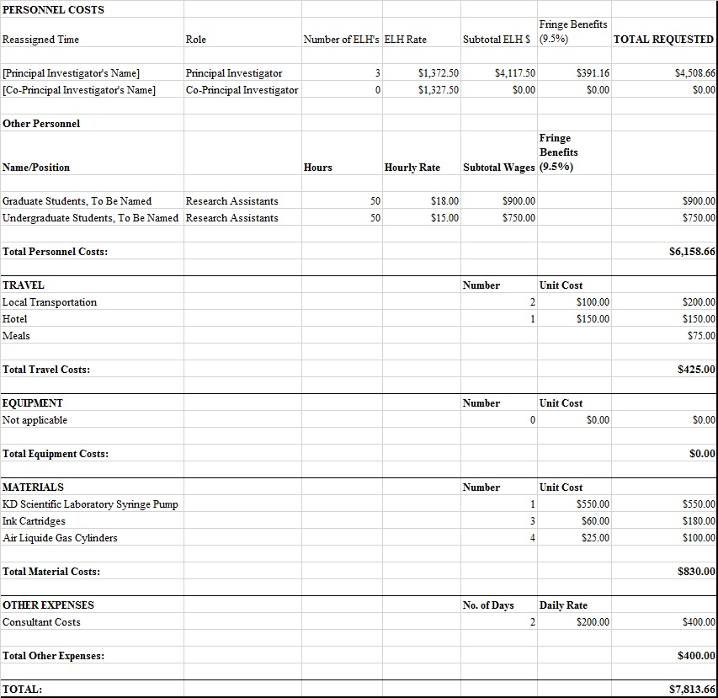

Personnel:
The Principal Investigator will be responsible for the conduct of the project in collaboration with the Co-PI, and will devote three (3) Equivalent Lecture Hours to the project during the fall semester, for which reassigned time is requested at a rate of $1372.50 per ELH. The total, including 9.5% fringe benefits, will be $4508.66
The Co-Principal Investigator will share responsibility for the conduct of the project and will contribute 1 month of effort to the project during the academic year at no cost to the grant.

One (1) to-be-named NYIT Graduate Student and one (1) NYIT Undergraduate Student will participate in the project as Research Assistants, for which they will be paid at a rate of $18.00 and $15.00 per hour, respectively. Each RA will devote 50 hours to the project. Wages for the graduate and undergraduate RAs will total $900, and $750 respectively.

Travel:
The PI will visit the field site to set up and calibrate the equipment and to collect air samples, for which partial travel support, in the amount of $425.00, is requested. This amount will cover two (2) cab fares at $50.00 each ($100.00), hotel for one night ($150.00), and meals for one person ($75.00).
Travel costs for the Co-PI for the purpose of sample collection will be defrayed by his school.

Equipment:
See Materials.

Materials:
One (1) KD Scientific Laboratory Syringe Pump will be purchased at a unit cost of $550.00. This device is an integral component of the sampling apparatus and is considered essential for the project.
Three (3) ink cartridges will be purchased at a unit cost of $60.00 (Subtotal: $180.00), for the purpose of generating high-resolution color images and graphical comparisons for data analysis and presentation. In addition, four (4) CO₂ cylinders, required for the trace gas extraction system, will be purchased from a supplier (Air Liquide) at a unit cost of $25.00, including shipping and handling (Subtotal: $100.00).

Consultant:
A statistical consultant will be retained at a rate of $200.00/day for 2 days, to assist with data analysis and the evaluation of errors due to ion corrections. The total requested for consultant costs is $400.00.

TOTAL:
The total requested for Personnel Costs ($6158.66, including reassigned time and fringe benefits, and Other-Than-Personnel Costs (Travel + Materials + Other Expenses: $1,655.00) is $7813.66

Remember to include a brief explanation and justification of each item, and to budget for 9.5% fringe benefits for any reassigned time, or for hourly wages for NYIT personnel, but not students. NYIT will pay the current Internal Revenue Service standard mileage rate for official travel by private automobile, based on the actual driving distance by the most direct route. NYIT will reimburse the reasonable cost of meals for overnight travel. Receipts must be submitted. Equipment of <$5,000.00 unit cost should be included with Materials rather than with Equipment. Capital equipment of >$5,000.00 unit cost should be categorized as Equipment.

